Pedigree Charts Worksheet

Background Information:

Pedigree charts are very important to many different fields of science. One reason they are important is because, they help scientists understand the genetic patterns of diseases. It is important to be able to interpret pedigree charts in order to learn the pattern of a disease or condition.

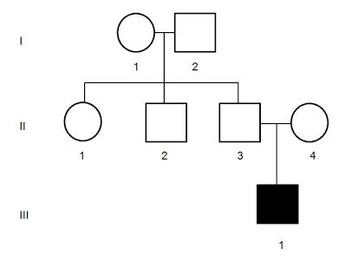
Before you start this activity it is important to know several symbols and conventions:

Unaffected female

Unaffected male

Affected female

Affected male

In a pedigree,
- Two individuals who are married/mated are connected with a horizontal line
- Siblings are drawn in birth order, from left (oldest) to right (youngest)
- Siblings are connected with a horizontal line above the symbols, with small vertical lines connecting the symbols to the horizontal line
- The horizontal sibling line is joined to the parent marriage/mating line by a vertical line

Example: A male and a female parent have two children, the first is a girl and the second is a boy. Draw a pedigree for this family.

Questions:
- How can you tell if a couple is married on a pedigree? Write a one sentence description and draw an example.

- How can you tell if a couple who are married had children? Write a short description and draw an example.

- Draw a pedigree that represents Mary, who is married to Greg. They have 2 sons (Scott and Tyler) and 1 daughter (Karen). Label the pedigree with the names of the people.

- Draw a pedigree that shows Julie married to Jeff, with one daughter, Josephine. Josephine married Joseph and had two sons, Jason and Jarrod. Jarrod married Jane and had three children, Sharon, Mark and Alex. Alex married Alison and had two children, Ray and Louise.

- A brown eyed woman marries a brown eyed man. They have two children, a girl with blue eyes and a son with brown eyes. Draw a pedigree for this family, where blue eyed individuals are show as shaded. Label the pedigree with the genotypes of the individuals. Where there are two possibilities, list both. Use your own key.

- Draw a pedigree for the following family. Label all the genotypes of the individuals. A brown eyed male and a brown eyed female have three children, a brown eyed daughter, a blue eyed son and a brown eyed son. The brown eyed son marries a woman, who also has brown eyes and they have a blue eyed daughter. Use your own key.

- Stuart and Veronica got married and had Brittany, Kristen and Harry. It was discovered that Harry had the recessive condition albinism. Brittany married Larry and they had two children, Stephan and Stephanie. Stephan also had albinism. Larry’s brother Barry also had albinism but neither of their parents had the disorder. Draw a pedigree for this family. Label all the individuals with their genotype. Use your own key. (Hint: Individuals with albinism should be shaded and albinism is a recessive condition.)

- The pedigree below shows the members of a family who have blue eyes. Label each individual with their genotype. Use your own key.

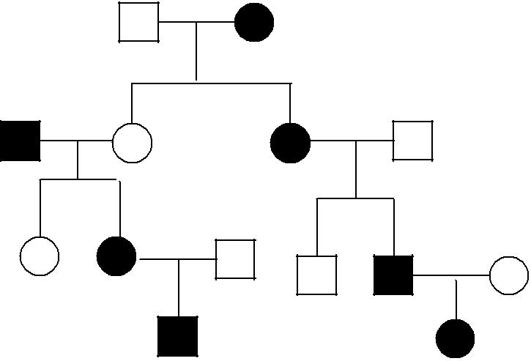

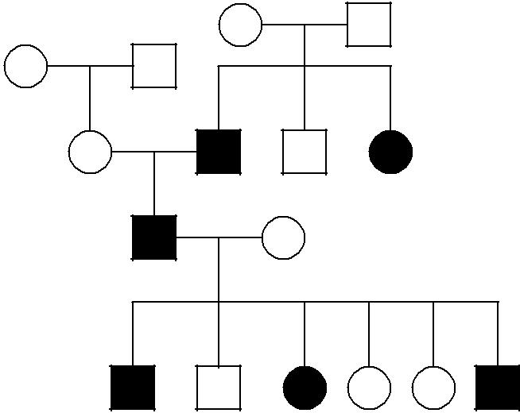
- The following pedigree shows albinism in a family. Label each individual with their genotype. Use your own key.

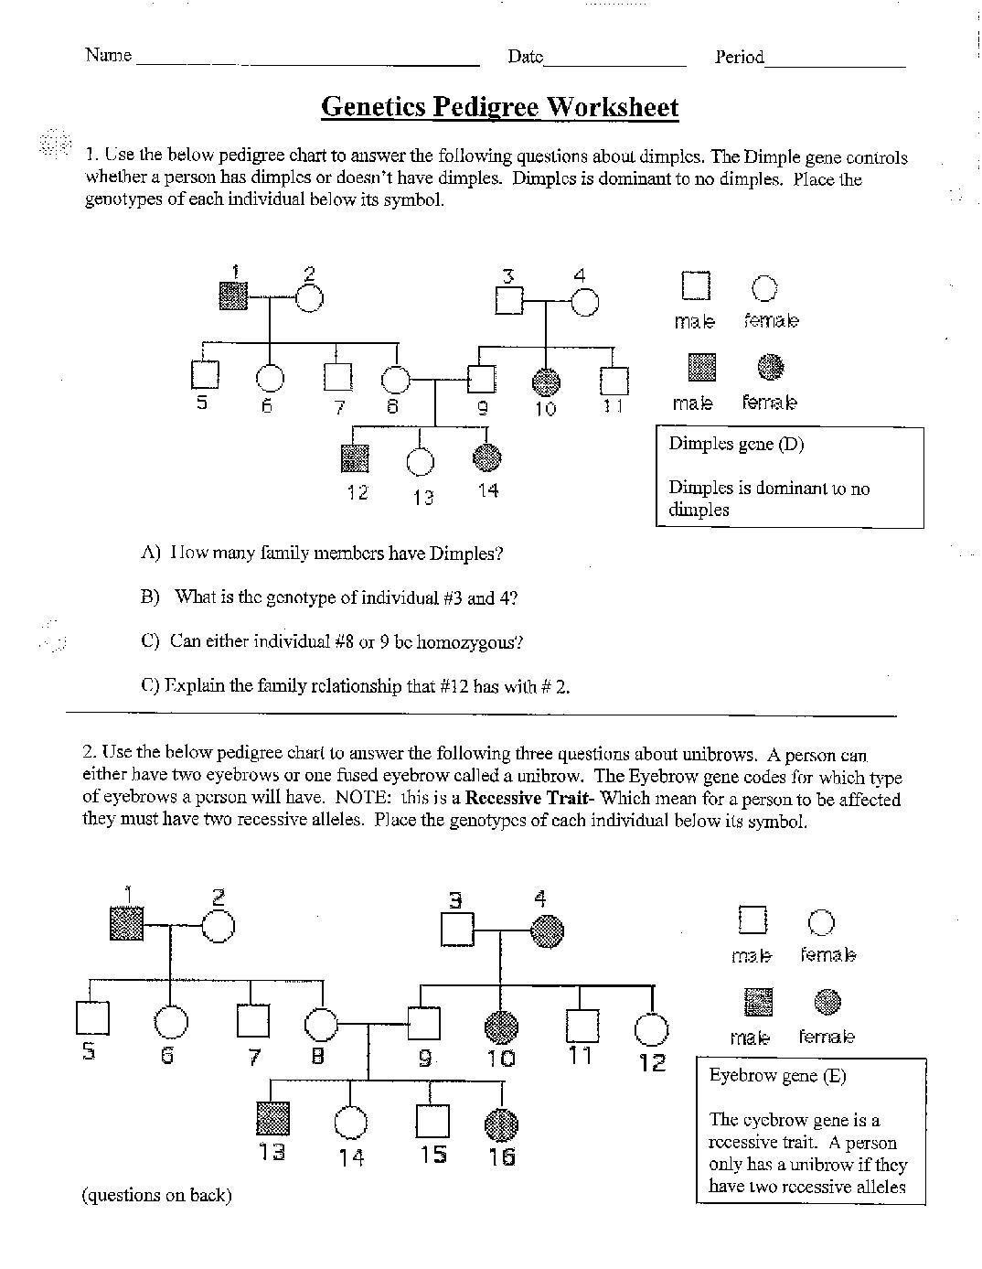
- Use the pedigree below to answer the following questions about dimples. The dimples gene controls wither a person has dimples or doesn’t have dimples. Dimples are dominant to no dimples. In this pedigree, individuals without dimples are shaded. Use your own key.

  - How many family members have dimples?

  - What are the genotypes of individuals #3 and #4? Give a reason for your choice.

  - Can either individual #8 or #9 be homozygous? Explain your answer.

  - What is the relationship between individuals #12 and #2?

  - Write the genotypes of each individual below their symbol.

- Use the pedigree below to answer the following questions about unibrows. A person can wither have two eyebrows or one fused eyebrow. Two eyebrows is the dominant trait and a fused eyebrow is the recessive trait. Use your own key.

  - How many family members have unibrows?

  - What is the genotype of individual #4?

  - Are individuals #8 and #9 homozygous or heterozygous? Explain your choice.

  - Write the genotype of each individual below their symbol.

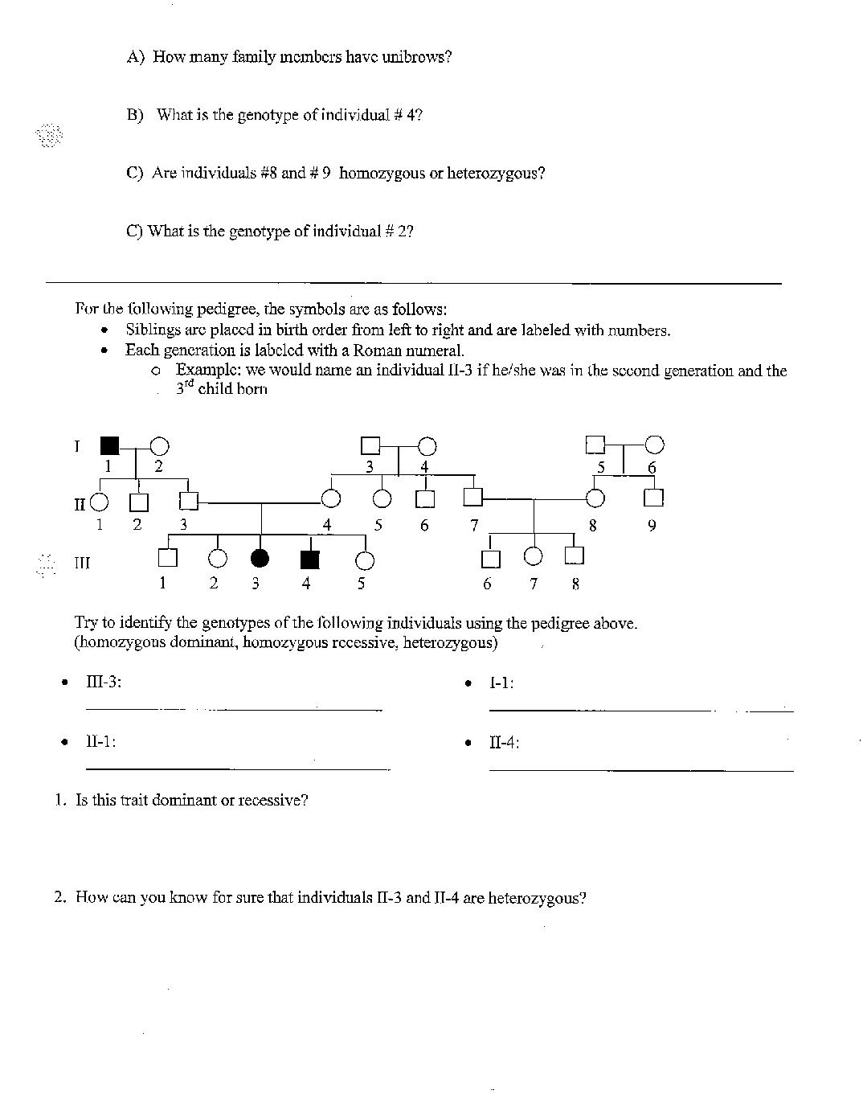
- In the pedigree below, each generation is labelled with a roman numeral. Individuals in each generation are labelled with a number.

  - Is this trait dominant or recessive? Explain your choice.

  - How do you know that individuals II-3 and II-4 are heterozygous?

  - Identify the genotypes of the following individuals. Use your own key.
III-3: _____ I-1: _____ II-1: _____ II-4: _____

